The Shiny app developed has five tabs that help users explore and interrogate the given topic of Coronavirus (COVID-19) and the dataset provided to complete this assignment. The following report may be used as a guide for the Shiny app that has been developed. This document will talk users through all the functionalities that have been built into the app.

**How to use the app:**

1. A screenshot of a cell phone

   Description automatically generated**Home Page**

This tab is the default home screen of our Shiny App. We have incorporated a dark and light mode option into our app which allows users to decide between the two. In order to switch between the two, one needs to click on the checkbox/sun icon in the top left corner.

Users can hover over the tab names to get a tooltip with a brief description about what can be found in that tab.

For the purpose of this *How to Guide* the images used will show the app in its dark mode.

1. **Map tab**

The map allows users an interactive experience as they explore the dataset. The circles on the map only reflect the most recent available data points. The markers change in size and colour as Confirmed cases rise.

The interactive elements of this map include:

1. Zoom in and out of the map using the plus and minus sign in the top left corner.
2. By clicking on the magnifying glass icon, in the top left corner, users can search for any country in the dataset. When clicking enter it will take them to this data point.
3. In order to revert to the original view of the map users can click on the icon below the magnifying glass and they will be taken back to the original view.
4. If some users feel the map is too clustered with too many data points being shown, we allow users to choose what data they would like to see on the map based on the count of confirmed cases. We have divided our data into three groups: *Lowest Confirmed Case Countries, Medium Confirmed Case Countries* and *Highest Confirmed Case Countries.* We have done the above by ranking each country according to their Confirmed case amounts. The icon of three stacks in the top right corner allows users to choose what groups’ data should be present on the map. It also allows users to choose between three map styles: *OSM, Carto* and *Black World.*
5. **Plot tab**

This tab allows users to plot scatter plots or line graphs that points that track the number of confirmed cases in each country over time. The default plot has Confirmed cases on the y-axis and the Date on the x-axis. Users can click in the white open space under Country and select any country to plot its respective data. The plot allows for multiple countries data to be displayed on the one set of axes – this allows users to compare different countries over time.

Users can customize their plots in the following way:

1. What country(ies) they want the data shown for shown
2. What time frame is used
3. The size of the points on the plot (1-5)
4. Whether or not they want a line plot to be shown instead of just points
5. If they would like to use a log scale or not
6. Users can also choose between three variables used on the y-axis. They have the option between: Confirmed, Recovered and Deaths.
7. The opacity of the points (this is handy when a few countries are chosen so that each data point is present and not covered by another)

Another feature of the plot tab and the table tab is the ability for users to download a copy of all the countries data that they have selected in the Country pull down. One simply does this by clicking on the Download button.

1. **Table tab**

This tab allows users to choose different countries in order to create a table that displays each country’s respective data. The table has five columns; County, Date, Confirmed, Recovered and Deaths.

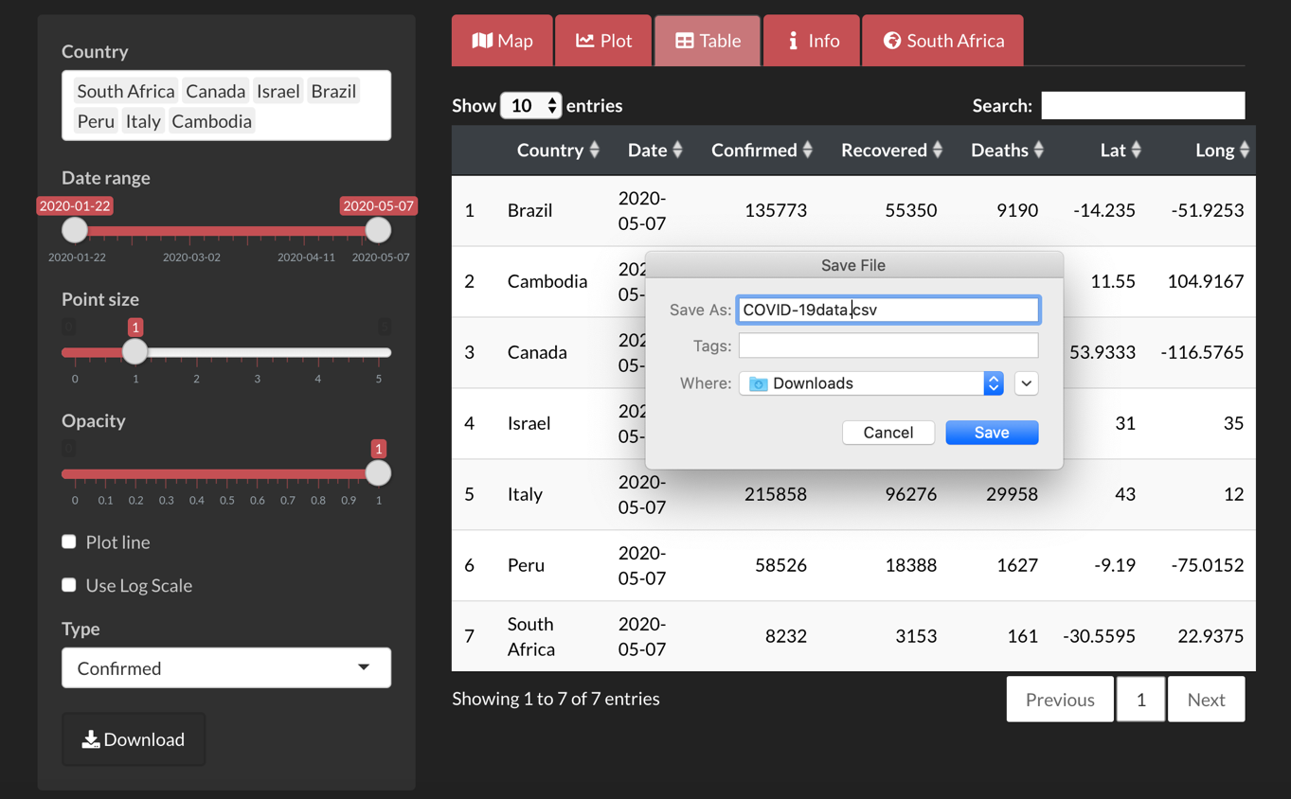

The data in the table can be adjusted using:

1. The Country drop down, which allows users to select which countries they would like in their table.
2. Users can also change the Date column with aid of the *Date Range* slider in the panel on the left. Sliding the circle on the right in this panel allows users to change the date variable in the table which will result in the Confirmed, Recovered and Deaths figures to change with the date, respectively.

Other functionalities of this tab:

1. Users can search any country in the table using the search box in the top right-hand corner.
2. Users are also able to select how many rows of data is displayed in the table.
3. Download the data from the table
4. **Info tab**

The Info tab provides users with information on COVID-19. The information used in this page was sourced from reliable sources such as the World Health Organization (WHO) and the National Institution for Communicable Diseases (NICD). This page aims to answer some questions users might have regarding the virus and what they can do to protect themselves from the virus and flatten the curves they have seen in the Plot tab.

This tab also has links to some thought provoking articles that users may be interested in. The Info tab concludes with an animated video on COVID-19. We included this video as some users may prefer to watch a short clip answering the majority of the questions on the info page instead of reading through each answer.

1. **South Africa tab**

As both developers are South African, we decided to include a tab that discusses the effects of COVID-19 on South Africa. This tab looks at what South Africa is doing to try flatten the curve and prevent the spread of COVID-19. Included in this tab are a videos of President Cyril Ramaphosa addressing the nation regarding the measures the government will/has been taking in order to prevent the spread of the virus and another of him explaining the measures that will be taken in order to help those grossly affected by the virus.

We also thought we could use this app as a means to help our country by promoting the Solidarity Fund and other NGOs that have been set up in order to help those most affected by the pandemic. In doing so we have informed users what the Solidarity Fund aims to accomplish and provided a link that can be used in order to get the correct banking details in order to make donations to the cause.

**Reference:**

NICD. 2020. *Frequently Asked Questions - NICD*. [online] Available at: <http://www.nicd.ac.za/diseases-a-z-index/covid-19/frequently-asked-questions/> [Accessed 25 April 2020].

World Health Organization. 2020. *Coronavirus*. [online] Available at: <https://www.who.int/health-topics/coronavirus#tab=tab_1> [Accessed 25 April 2020].